General information (this paragraph to be deleted before submission):
Text: Times New Roman, 11, interlining: simple
- Length: 4 to 5 pages maximum including tables, figures and references.
- 2 tables and 2 figures maximum (see template below)
- No more than 20 references.

Enter the title of the extended abstract here (Times New Roman, 12, bold, lower cases)
Firstname Name^{1*}, Firstname Name² and Firstname Name³ (Times New Roman, 11)
ex: Maria Kanwald^{1*} and Pietro Genovesi^{2*}
¹Affiliation of the first Author (Times New Roman, 11)
²Affiliation of the second Author (Times New Roman, 11)
ex: ¹The University of Melbourne, Parkville, 3010 Victoria, Australia

*Corresponding author: xxxx@xxx.com (e-mail only)

Keywords: Enter keywords here, keyword1, keyword2, … keyword5 (Times New Roman, 11)

Abstract:
Enter abstract here (200 words maximum; Times New Roman, 11)
Introduction:
Enter introduction here (Times New Roman, 11)
Materials and methods:
Enter materials and methods here, 1 page maximum (Times New Roman, 11)
Results and discussion:
Enter results and discussion here (Times New Roman, 11)
Conclusion:
Enter conclusion here (150 words maximum, Times New Roman, 11)

Table 1. Legend of table 1 here, above the table (Times New Roman, 11, bold).
 | A | B | C | a | b | c
Enter your text here | 3.353* | 0.08 | 0.621 | 230.5 | 39.42 | 17.11
Enter your text here | 3.201 | 0.101 | 0.502 | 365.2 | 33.93 | 16.23

Foot note of table 1 (Times New Roman, 11).

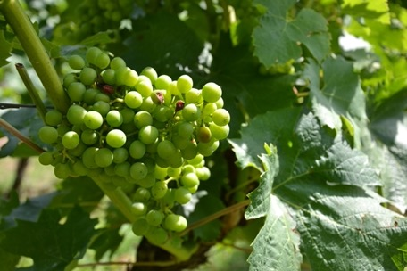

Figure 1. Title of figure 1 here, under the figure (Times New Roman, 11, bold).

Foot note of figure 1 (Times New Roman, 11).

References:
Enter the references here (APA style, Times New Roman 10, interlining: simple)
Name, A. A, Name, B. B, & Name, C. C. (2010). Title of the document. Journal, 21(1), 57-75. https://doi.org/xxxxxxxxxxx
Name, F. (2013a). Title of the document. Journal, 31(3), 466-467. https://doi.org/xxxxxxxxxxx

